RAS test book

# Revision history

|  |  |  |  |
| --- | --- | --- | --- |
| **Version** | **Date** | **Author** | **Description of revision** |
| **0.1** | 2017-11-27 | B. Dijck | First draft |
| **0.2** | 2017-11-30 | B. Dijck | Minor update |
| **0.3** | 2017-12-13 | Ives vd Flaas | Minor update |
| **0.4** | 2018-01-24 | B. Dijck | Minor update (test different browsers) |
| **0.5** | 2018-01-24 | B. Dijck | Minor updates |
| **0.6** | 2018-03-06 | P. Meir | Added Data Analysis |
| **0.7** | 2018-03-06 | P. Meir | Expanded filter list tests + cleanup |
| **0.8** | 2018-05-16 | B. Dijck | Minor update |
| **0.9** | 2018-06-11 | B. Dijck | More tests on Data Analysis Engine |
| **0.10** | 2018-06-12 | B. Dijck | Minor updates after production release test |
| **0.11** | 2018-07-09 | B. Dijck | Add placeholder for Most recently used items |
| **0.12** | 2018-10-18 | Ives vd Flaas | Single asset detail |
| **0.13** | 2018-11-16 | Ives vd Flaas | MRU & Transfer of ownership |
| **0.14** | 2018-12-14 | Ives vd Flaas | Add reports, remove events, user security |
| **0.15** | 2019-01-08 | Ives vd Flaas | Move items, remove duplicate |
| **0.16** | 2019-01-31 | Ives vd Flaas | Registration, property metadata |
| **0.17** | 2019-02-30 | Ives vd Flaas | Remove asset type section |
| **0.18** | 2019-03-13 | P. Meir | Added 2FA tests and AssetType |
| **0.19** | 2019-03-26 | Ives vd Flaas | Fix date format |
| **0.20** | 2019-03-26 | Ives vd Flaas | Property metadata & static properties |
| **0.21** | 2019-05-22 | Ives vd Flaas | Update report section |

# Table of contents

1 Revision history 1

2 Table of contents 1

3 Software to be tested 1

3.1 Access to the application 1

4 Test suite 2

4.1 Access to the application 2

4.2 Administration 3

4.3 Assets screen 4

4.4 Filters 4

4.5 Dashboards 5

4.6 Reports 6

4.7 Event Fout! Bladwijzer niet gedefinieerd.

4.8 Scheduled tasks 9

4.9 Web notifications 11

4.10 User security 12

4.11 Web browser support 12

4.12 Data Analysis 14

5 Test results 16

# Software to be tested

## Access to the application

* URL: <http://ghent:80>
* Login credentials:
  + User: test@test.com
  + Password: ask RAS development team
* It is possible that some tests require additional credentials but these should be specified in these specific tests.

# Test suite

This section contains all the tests that need to be executed to verify the functionalities contained in the RAS application.

The tests are grouped around the following domains:

* Access to the application
* Administration
* Assets
* Filters
* Dashboards
* Data Analysis Engine
* Reports
* Events
* Scheduled tasks
* Web notifications
* User security

Ideally, each test should contain the following elements:

* Pre-conditions for the test
  + e.g. a dashboard must already be shared with another user
* Execution steps
  + e.g. ‘click on the ‘submit’ button’
* Expected result
  + e.g. the preview data should only contain values between 5 and 10

## Authentication

### Standard authentication

|  |  |  |  |
| --- | --- | --- | --- |
| ID | Preconditions | Steps | Expected result |
| 2 | User is not logged in | login with wrong username | should fail |
| 3 | User is not logged in | login with wrong password | should fail |
| 4 | User is not logged in | login with username that is not a valid e-mail address | should fail |
| 5 | User is not logged in | login with correct username and correct pwd | should work  logged in user is printed at top |
| 6 | User is logged in | logoff, and try to use RAS after pressing browser <back> button | using RAS should not be possible (selecting an item in the menu on the left) |
| 7 | User is logged in | click ‘hello <username>’ in home screen | profile page should be shown |
| 8 | User is logged in | change password, provide invalid old password but valid (and equal) new and new confirmed passwords | error “incorrect password” should be shown |
| 9 | User is logged in | change password, use valid old password and use “testtest” as ‘new password’ and as ‘confirm new password’ | error about minimum password requirements should be shown |
| 10 | User is logged in | change password, provide valid old password but differing new & confirm passwords | error about differing new & confirm passwords should be shown |
| 11 | User is logged in | change password, login with old pwd | login with old should fail |
| 12 | User is logged in | change password, login with new pwd | login with new should work |

### 2FA Authentication

#### Setup 2FA for user

* Open user profile by clicking on the email address top right
* Click on the link “Setup Two Factor Authentication”
* Use a smartphone with an 2FA authenticator app or install the chrome extension Authy and scan the displayed QR code
* When scanned successfully, click the Confirm and Enable 2FA button
* You’ll be redirected to the login screen
* Enter your login information again (with the same user you’ve setup 2FA for)
* Click the Login button
* Open the 2FA app and get the currently valid 2FA token
* Enter this token in the input field
* Click the “Verify Token” button
* Validate that you are now logged in

#### Regular 2FA token login

* Logout of RAS
* Enter your login information for the user which has 2FA enabled (see 4.1.2.1)
* Click the Login button
* See that the 2FA screen appears
* Enter your currently valid 2FA code (using your 2FA app)
* Click the “Verify Token” button
* Validate that you are now logged in

If you want to remove 2FA from a user, please ask one of the RAS developers.

## Administration

### Manage users

* create user (+ test login using newly created user)
* impersonate (+ test permissions)

Testing of permissions and web notifications happens in section 4.

Ask a developer to delete the newly created user (w/ permissions)

### Manage companies

* screen should show all companies
* create new company

Ask a developer to delete the newly created company.

### Manage assets

* create new asset
* set associated companies
* change ftp password (and test FTP) (*)
* change asset image

(*) Note: on GHENT it is not possible to test FTP.

### Manage Asset Types

* Screen should show all asset types
* Create new asset type

### Manage Data Chunks

* only x records are loaded initially, but by scrolling down additional records are added to the table
* Records are sorted: most recent at the top
* Logfiles can be downloaded by clicking the download icon in the last column
* Logfiles can be viewed online by clicking the ID in the first column

## Assets screen

### List of assets

* The screen should show the list of all the assets that are available for the company (that the user belongs to), and only these assets.
* The screen should not show any asset that is not linked to the company the user belongs to.
* Images should be shown for every asset that has an avatar in the list.
* Clicking a card (box in UI showing details of single asset), should bring up the asset detail screen

### Single asset detail

Test when logged in with a user with administrator privileges:

* The screen should show the following tabs: general information, device properties, custom properties, log, control center, filters, dashboards, reports, log files, property metadata, asset statistics.

Test when logged in with a user without administrator privileges:

* The screen should show the following tabs: (all of the previously mentioned tabs other than Log Files & Property Metadata, which should not be visible).

### Property metadata

Pick an asset, and navigate to that asset’s detail page. Make sure your current user has administrator privileges, and open the Property Metadata page.

Check general operation:

* When going to edit mode, fields become editable
* When going from edit to display mode (“save”), fields are no longer editable
* When going from edit to display mode, the entered changes persist
* When refreshing the page, changes persist.

### Custom Properties

Pick an asset, and navigate to that asset’s detail page. Open the Custom Properties tab.

* Create a new property with a name of your choosing, and a (decimal) value of your choosing. Add this property.
* Now create a second point by keeping the property name the same, but changing the timestamp and value.
* Confirm the most recent value for the newly created property is visible.
* Create a dashboard that visualizes the newly created property to confirm the values are actually in the database.

## User Registration

### Step 1: Token Creation

* Log in using an account with administrator privileges.
* Navigate to the administrator user listing page
* Click the “Create Registration Token” button
* Pick the company you’d like associate the new user(s) with.
* Choose some set of permissions and remember which ones you picked.
* Pick a number of tokens.
* Click the submit button.

### Step 2: Token sharing

In this step, we’ll share the creation link with the user who will create the new account.

Fill in the target email address, check the subject and content and send the email to an address you control. Check to see if the email arrives.

### Step 3: Account creation

Log out if you are still logged in, or use an anonymous browsing window. Click the link that was received by email in the previous step.

You’re shown a registration screen. Fill in all fields. Note that the email address you specify will be used to send a confirmation email.

* Try using a password that’s short (should not be allowed).
* Try mismatching the first and second password (should not be allowed)
* Try using an email address that already has a RAS account coupled to it. This should not be allowed.
* Enter an unused email address you control and a valid & secure password.

### Step 4: Confirmation

Check that you’re shown a confirmation page which explains how you should check your email.

At this point, your email address has not been confirmed. Try to login with the username & password you provided and confirm you are *not* able to login.

### Step 5: E-mail Confirmation

Confirm you’ve received an email telling you about how your RAS account registration has almost been completed. Click the link that’s contained in the email.

### Step 6: E-mail Confirmation Congratulations

Confirm you’re shown a page that tells you how your email address has been confirmed.

Confirm that the Login button that’s visible on this page redirects you to the login page.

Try to log in with the email address and the password you provided in the earlier steps and confirm you are successful in logging in.

Confirm that the new user account has all of the feature level security permissions that were specified in the very first step, but none that weren’t specified.

Confirm that the new user account has access to the expected assets, based on the company this user is associated with. Other users with the same company will have access to the same assets.

## Filters

### List of filters

* The screen should show the list of all the filters that are available for the user. This includes: filters that are created by the user and filters that are shared with the user
* Filters that are created by the user:
  + have edit, export and delete button
  + have a share icon showing the number of shares
  + have a clickable title that takes the user to the edit filter screen
* Filters that are not created by the user (i.e. shared with the user):
  + have export and unlink button
  + have no share icon
  + do not have a clickable title

### Create a new filter

* Wizard…
  + Each tab: check all UI-controls/elements (!)
  + Tab 1: check correct list of assets is shown
  + Tab 2: check correct properties are listed
  + Tab 3: check ‘data filters’
  + Tab 4: check ‘timestamp filters’
  + Tab 5: check preview

### Edit an existing filter

* Clicking ‘edit’ should bring user to the same wizard as for the create
* Functionality is the same as create

### Delete a created filter

* Cannot delete filter that is in use by dashboard
* If the user tries to delete a filter that is shared by the user with other users, a warning message should be displayed after the user clicks ‘delete’
* If the user has deleted a filter that is shared by the user with other users, then this filter should not be in the list of filters anymore for those other users.
* A filter that is not shared, nor in use by a dashboard can be deleted without any warning other than the one that’s always shown when deleting filters.

### Export filter data

* User can export the filter data to CSV after clicking ‘export’.
* After clicking ‘export’, a message is shown.
* Data export should not take longer than 5 minutes
* When export is complete:
  + email should be sent to user
  + web notification should be shown
  + both messages contain a link to the same csv export file
* exported file is correct

### Filter sharing

* Share filter
* Unlink filter
* Accept share invitation
* Try to accept share invitation twice
* Refuse share invitation

## Dashboards

### List of dashboards

* The screen should show the list of all the dashboards that are available for the user. This includes: dashboards that are created by the user and dashboards that are shared with the user.
* Dashboards that are created by the user:
  + have view, edit, duplicate and delete button
  + have a share icon showing the number of shares
  + have a transfer of ownership icon
  + have a clickable title that takes the user to the dashboard detail screen
* Dashboards that are not created by the user (i.e. shared with the user):
  + have view and unlink button
  + have no share icon
  + have no transfer of ownership icon

### Create a new dashboard

* Drop-down list of filters should contain filters that are created by the users and filters that are shared with the user
* The <edit> button next to the drop-down list of filters should only be enabled for filters that are created by the user, not for those that are shared with the user
* After the dashboard is created, the card in the dashboard list should include an image preview of the dashboard.

### Edit an existing dashboard

* Clicking <edit> should bring user to the same UI as for the create

### Duplicate an existing dashboard

* Clicking <duplicate> should bring user to the same screen as for editing a dashboard.

### Delete an existing dashboard

* Click <Delete>.
* If the user tries to delete a dashboard that is shared by the user with other users, a warning message should be displayed after the user clicks ‘delete’
* If the user has deleted a dashboard that is shared by the user with other users, then this dashboard should not be in the list of dashboards anymore for those other users.

## Reports

### Creating a new report

* Navigate to the Reports list through the menu on the left.
* Click the “create new report” button.
* Confirm the report editor is blocked, because no filter has been selected.
* Select a filter that contains some amount of data
* Find the XRTable block in the toolbar on the left, drag it to the Detail1 block.   
  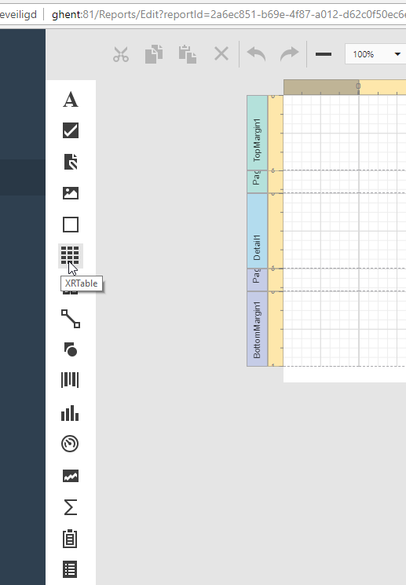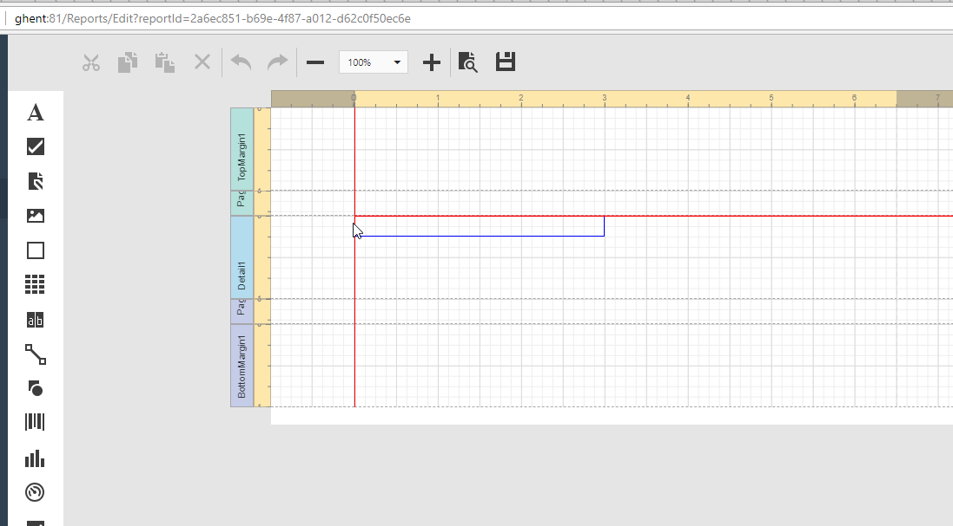  
  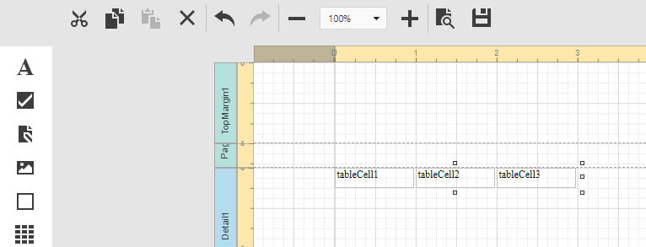
* Click the field list button on the right:   
  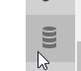
* Open the field list to the point where the property you’d like to display is visible:  
  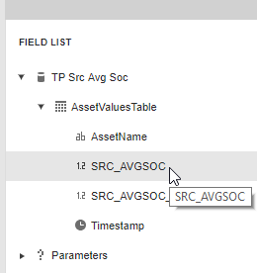
* Drag this property and drop it in the leftmost column of the table you created earlier:  
  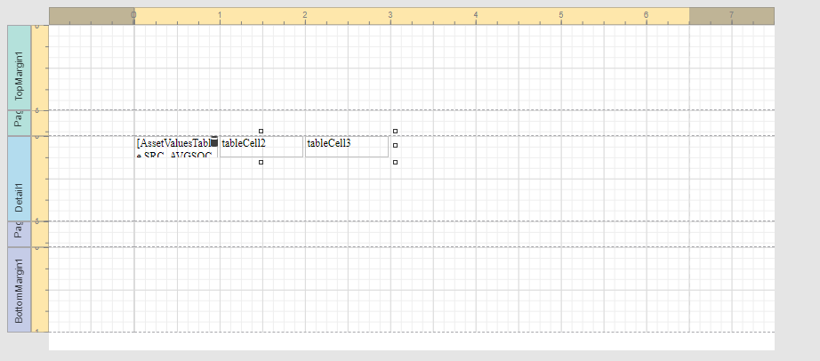
* Click the save button near the top:  
  
* Confirm a report saved bar appears near the bottom of the screen (after a small delay):  
  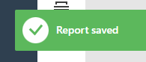
* Click the preview icon near the top:  
  
* Confirm a preview containing the data you selected appears:  
  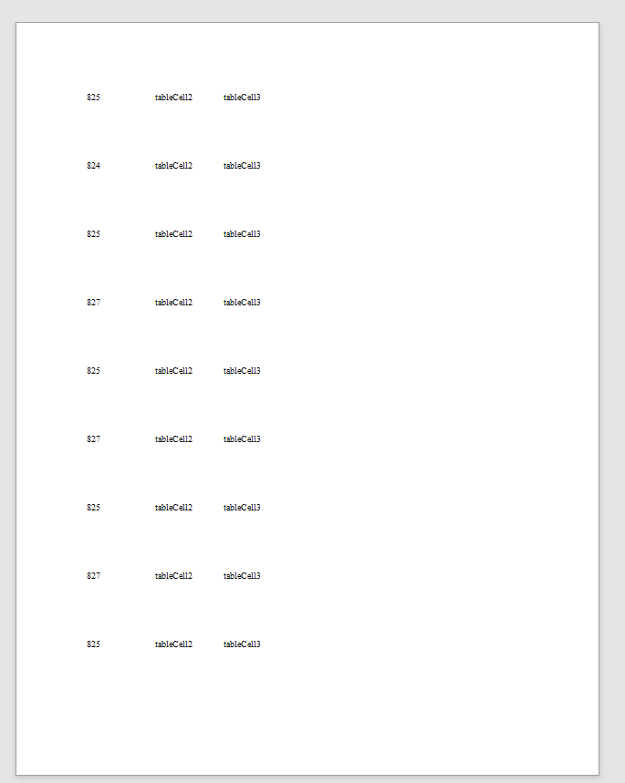
* Go back to designer mode by clicking the Designer button:  
  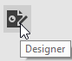
* We will now configure the report title. In the toolbar at the top, click the Edit Title icon:

.  
Enter a title of your choosing and press the OK button.

* Click the save button once more and wait for the “saved” message to appear.
* Click the “reports” link in the leftmost menu bar.
* Confirm the report you created is visible.
* Confirm the filter listed under the report is the one you selected.
* Confirm the transfer of ownership, share, view, edit, delete buttons are visible.

### Edit a report

* Click the edit button under the report you created in the previous step.
* Confirm the table grid you added is still present, and the data binding is still visible.
* We will change the title now. Click the grey area under the page once more.
* Open the DESIGN block on the right.
* Change the title. Once more, use only letters and digits, no spaces.
* Click the save button near the top.
* Click the reports link on the left.
* Verify the name of the report has changed to the one you chose.

### Viewing a report

* Click the “view” button under the report you created & edited in the previous steps.
* Confirm the data from the filter you selected is visible.

### Deleting a report

* Click the “delete” button under the report you created in the previous steps.
* Confirm you are shown a warning that adequately warns you of what you’re about to do.
* Click cancel.
* Confirm the report is still there.
* Click the “delete” button again
* Click the “Yes” button this time
* Confirm the page reloads, and that when it does, the report you deleted is gone.

## Scheduled tasks

### Create a new scheduled task

* Tab 1
  + Select ‘based on a fixed schedule’.
  + Set schedule to trigger every minute
* Tab 2
  + Select any dashboard.
* Tab 3
  + Check box ‘send an e-mail’
  + Check box ‘send a website notification’
* After 1 minute of waiting, the website notification and e-mail should be received.

### Instantly run a schedule task

* On an existing scheduled task, click ‘run now’.
  + The website notification and e-mail should be received.

### Edit a schedule task

* Click <edit> for an existing scheduled task.
* User should be taken to the same UI as for the creation of a scheduled task.

### Delete run a schedule task

* Click <delete> for an existing scheduled task.
* User is asked to confirm deletion.
* After confirmation, the task should be deleted.

## Web notifications

### Send notification to user

* Pre:
  + need 2 separate accounts, user1 and user2
  + log users in using different browser sessions (e.g. user1 uses Firefox, user2 uses Chrome)
* send notification
  + use user1
  + go to administrator/manage users
  + Find <user2>
  + Click <sends web notification>
  + Enter any data
* Read notification
  + Use user2
  + Top of screen: bell icon should indicate that a notification is available
  + Notification message should contain the data that was entered by user1

## User security

* Navigate to the users summary in the administrator section.
* Pick a user that isn’t used in the environment you’re on.
* Revoke all of his permissions.
* Impersonate the user
* Check that the menu items for Dashboards, Reports, Data Analysis, Scheduled Tasks and Administrator are not visible. Only home & assets should be visible in the left menu.
* Log off & log in with your usual (administrator) account
* Go back to the users screen in the administrators area

### View permissions

* Give the user you’ve been modifying view_filters, view_dashboards, view_reports and view_data_analysis_definition permissions.
* Impersonate him again.
* Confirm you have the following menu items: Home, Assets, Filters, Dashboards, Reports, Data Analysis.
* Under filters, confirm that the create filter button is not visible, and that any filters visible have only an export button.
* Under dashboards, confirm that the create dashboards button is not visible, and that any dashboards visible have only their unlink & view buttons. They should also have clickable titles.
* Under reports, confirm that the create reports button is not visible, and that any reports visible have only their unlink & view buttons. They should also have clickable titles.
* Under data analysis, confirm that the create data analysis definition button is not visible, and that any dad’s visible only have their unlink buttons.

### Edit permissions

* Give the user you’ve been modifying edit_filters, edit_dashboards, edit_reports, edit_scheduled_tasks and edit_data_analysis_definition permissions.
* Impersonate him
* Confirm the scheduled task menu option exists and a create scheduled task button is present.
* Confirm filters, dashboards, reports and data analysis all have create buttons, as well as edit buttons.

### Admin permissions

* Give the user you’ve been modifying administrator permissions.
* Impersonate him
* Confirm the links to admin functionalities like Users, Asset Types, etc.
* Attempt to impersonate another user account.

## Web browser support

Testing web browser support can be done in many ways. The following is a basic set of tests.

|  |  |  |  |  |
| --- | --- | --- | --- | --- |
|  | Google Chrome | Firefox | Microsoft Internet Explorer | Microsoft Edge |
| Enter URL, access application |  |  |  |  |
| Edit a filter |  |  |  |  |
| View a dashboard |  |  |  |  |
| View an asset’s details screen |  |  |  |  |

Note: The list of supported browsers (and their versions) is not specified in this test document: this list should be specified elsewhere. In absence of such a list, the tests in this paragraph assume that the latest major version of each browser is used.

## Transfer of Ownership

### Filter

* Create a new filter, the contents of which do not matter.
* Click the  icon in the top right of the newly created filter card.
* Confirm the hierarchy diagram shows the name of the filter.
* Confirm a warning indicating the seriousness of what you’re about to do is shown.
* Enter your email adress as the recipient and click the button.
* Log out of RAS, and click the link you received the email.
* Log in when prompted
* Confirm the system asks you if you want to accept.
* Choose to accept the filter.
* Ensure the filter is present in your list of filters, as an owned filter (ie transfer of ownership and share icons visible).
* Check the contents (assets, properties, …) are the same as originally configured
* Log back into the account you originally logged in with, and ensure the filter is no longer present in this account.

Repeat this entire procedure, only refusing instead of accepting the transfer. Ensure the filter remains visible for the original user, and is not visible for the new user.

### Dashboard

Repeat the procedure mentioned in 4.11.1, but instead of only creating a new filter, create a new filter and a new dashboard based on that filter. Furthermore, create a second dashboard based on the same filter. Then transfer the dashboard instead of the filter. Verify the diagram when transferring shows both the dashboard and the underlying filter.

Once the transfer is complete, verify that the recipient has received both the filter and the dashboard. Also verify that the original owner’s second dashboard, the one which was based on the filter that was transferred as part of the dashboard transfer, still functions correctly. Check that the filter which was transferred is now shared with the original owner.

## Data Analysis Engine

We will test the proper function of the Data Analysis Engine by manually uploading multiple files, creating DADs and checking they have the results that were expected.

These test input files can be found on the same confluence page where this document could be found.

### Preparation

Create a new asset type and a new asset you will use in the tests. Remember the asset id that was assigned to this asset. Also note down the GUID assigned to this asset.

### First data

Place file 1.log in the unprocessed directory for the newly created asset. Verify the file disappears from the directory after a few seconds, and verify that a new datachunk is created with the expected contents (see content of file for expected contents).

### Create DAD

Create a new DAD with the following text:

with asset(63) as w  
define every(w.TEMPERATURE) as temp  
when 1 then writevalue(w.DAE_TEMP_KELVIN, temp+273, timestamp)

Substitute the asset id with the asset id of the asset you created. Save and enable the DAD. Wait a few seconds and verify that

* A new property DAE_TEMP_KELVIN was created
* It contains a single datapoint 290.11

### Modify DAD

Now modify the text so 273.15 instead of 273 is added to the temperature.

Check that there is still only a single value for the data series DAE_TEMP_KELVIN for the asset, but that the value has changed to 290.26. Also verify that the associated timestamp is the 14th of October 2018, at 08:29:30.

### Upload new data

Put the file 2.log in the unprocessed directory for the asset. Wait a few seconds. Verify that the file disappears. Wait another few seconds.

Check that there are now two datapoints associated with DAE_TEMP_KELVIN for the asset, the first as above, and a second on the 16th of October 2018, at 03:57:06 with the value 282.78.

### Web Notifications

Create a new webnotification template and add the clause to send a webnotification upon receipt of new data. Like so:

when 1 then writevalue(w.DAE_TEMP_KELVIN, temp+273.15, timestamp), webnotification("NotificationTemplate1")

Enter the following data into the notification template:

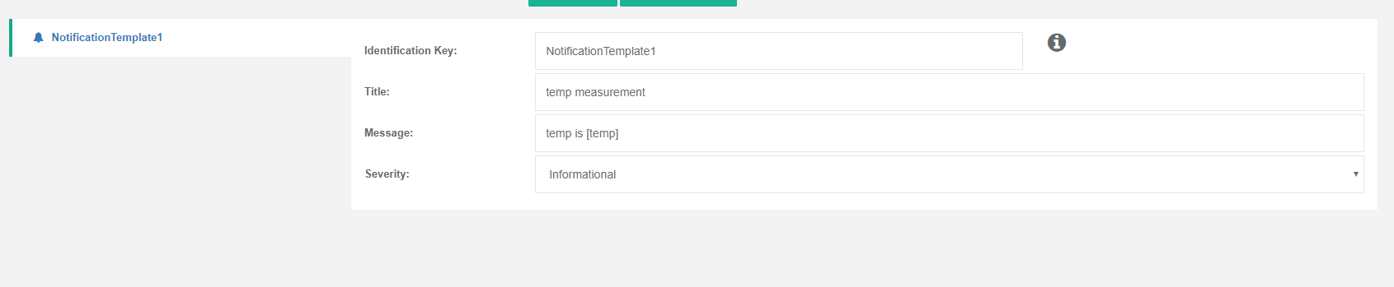

Save the DAD. This may generate a few webnotifications.

### More data

Upload file 3.log into the unprocessed directory for the asset. Check that the following notification is generated:

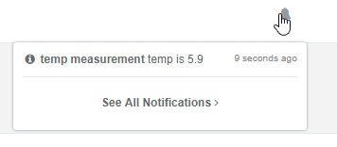

### Delete a DAD

* click on the 'delete' button on the Data Analysis screen
* answer 'yes, delete this definition' when prompted
* DAD should be removed

### Help pages

* edit a DAD
* click on help-hyperlink (upper right)
* help information should be available

## Most recently used items (MRU items)

### Dashboard

Open a dashboard & wait for it to load completely. Then open the Home page by clicking the Home link in the menu bar on the left and confirm that this dashboard is the first item listed.

### Filter

Edit a filter by changing its name. Open the Home page in the menu bar. Confirm that the Filter, visible by its new name, is the first item listed. Also confirm that the second item is the dashboard you opened in 4.13.1.

### Scheduled Task

Pick a scheduled task that already exists, and Run it. Open the home page and confirm the scheduled task you just executed is the first listed, followed by a filter and with a dashboard in third place.

### Report

View an existing report. Open the home page and confirm the report you just viewed is listed at the first position. Confirm it is followed by a scheduled task, a filter and a dashboard.

### Text Max Number of Items

Open/edit at least 9 different dashboards/filters/scheduled tasks & reports. Ensure that no more than 9 items are visible on the home screen.

# Test results

If during functional testing tests from this suite above are found to be failing, the failure should be registered in a ticketing system using a reference to the failed test and the tested RAS application:

* Reference to failed test
  + Test ID (e.g. 4.1.5)
  + Test document version ID (e.g. 0.6)
* Reference to the tested RAS application
  + Build reference (commit tag?)

Functional testing should produce a test report that contains:

* Time-stamp of when the test was performed (begin, end)
* Details of person(s) who performed the test
* RAS information that can identify the specific version of RAS (e.g. build number)
* Reference to log files that may be available.
* Reference to screenshots that may be available.
* A short summary table describing the test results, for example:
  + Number of test(s) successful: 125
  + Number of test(s) failed: 14
  + Number of test(s) not performed: 3
* An overview of the number of bugs (tickets) that have been created, for example:
  + Number of CRITICAL bugs logged: 2
  + Number of MAJOR bugs logged: 4
  + Number of MINOR bugs logged: 5
  + Number of OTHER tickets logged: 11
* ...